5. Web Server

Introduction

**Objective:**

At the end of this guide, you will learn to configure apache2.

**Login**

The login credential for all server and client machines:

Username: root / user

Password: Skill39@Lyon

**Network Topology**

This will be the network topology that will be referenced for setting up the infrastructure.

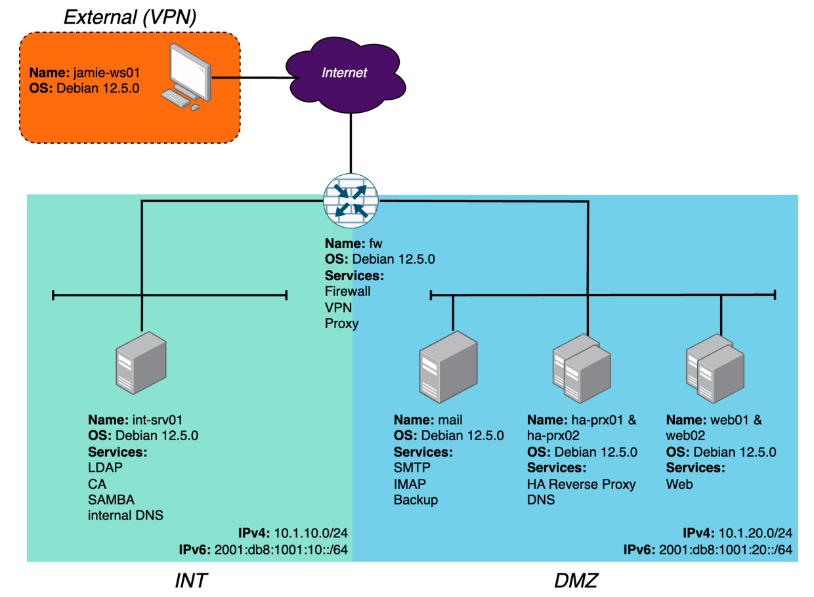

## Web Server

**Configure Web Server on web01 manually**

apt install apache2 -y

mkdir -p /opt/wwwroot

vim /opt/wwwroot/main.html

vim /opt/wwwroot/404.html

| Sorry, but something went wrong |
| --- |

vim /opt/wwwroot/whoami

| web01 |
| --- |

vim /etc/apache2/sites-available/000-default.conf

| <VirtualHost *:80>  ServerAdmin webmaster@localhost  DocumentRoot /opt/wwwroot/  DirectoryIndex main.html #change root page  ErrorDocument 404 /404.html # 404.html is served when an invalid path is given  ErrorLog ${APACHE_LOG_DIR}/error.log  CustomLog ${APACHE_LOG_DIR}/access.log combined  </Virtualhost> |
| --- |

vim /etc/apache2/apache2.conf

systemctl restart apache2

## Configure Web Server on web02 using ansible

We will set up ha-prx01 as the Ansible Server and manage web02.

### Setup Ansible

mkdir -p /opt/ansible

cd /opt/ansible

vim ansible.cfg

| [defaults]  inventory = ./inventory  host_key_checking = false  vault_password_file = .vault_pass |
| --- |

vim .vault_pass

| Skill39@Lyon |
| --- |

ssh-keygen -t rsa -b 4096

ssh-copy-id -i /root/.ssh/id_rsa.pub [root@10.1.20.32](mailto:root@10.1.20.32)

vim inventory

| [web]  web02.dmz.worldskills.org |
| --- |

ansible-vault create secretLinux

| ansible_connection: ssh  ansible_user: root  #password if passphrase is used when generating ssh key. leave it empty if no passphrase is used  ansible_ssh_pass:  #not needed if file name of the key is id_rsa  ansible_ssh_key_file: <file name if the default name for key id_rsa is not used> |
| --- |

**Use the below command to test connection between ha-prx01 and web02**

ansible all -u root -m ping

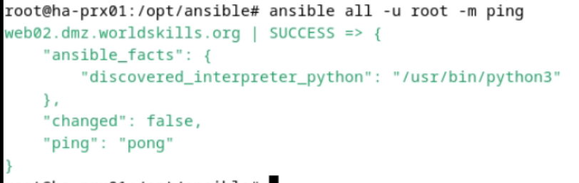

### Ansible Script

vim configure-web02.yml

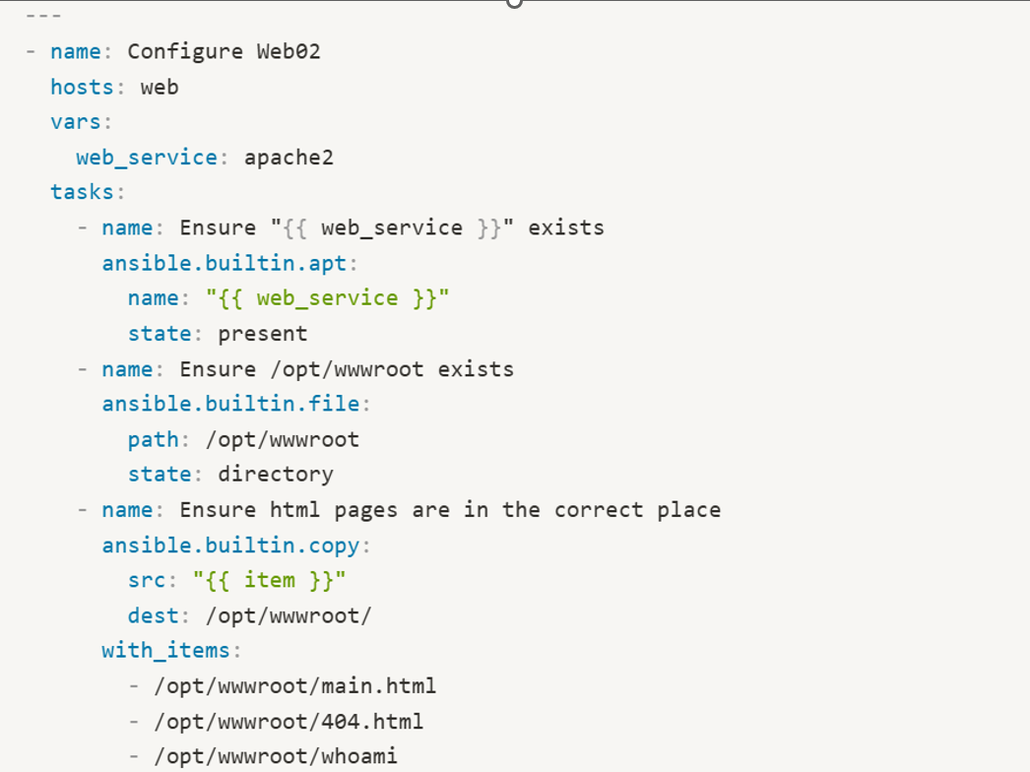

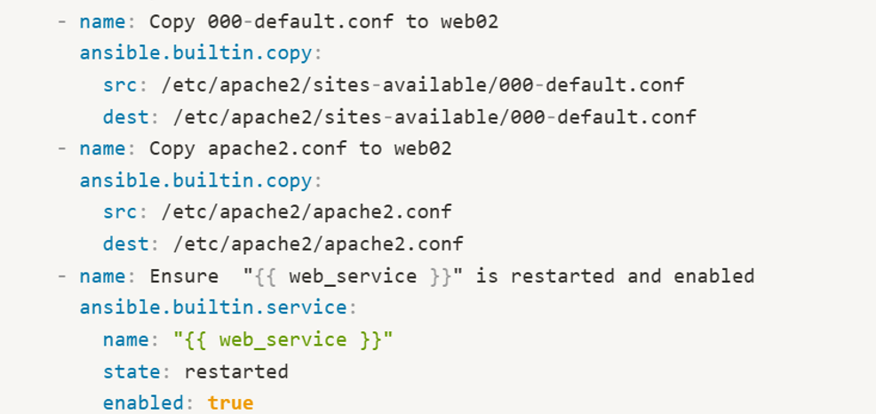

**In ha-prx01:**

Choose either options

| 1. run in /opt/ansible/ directory:   ansible-playbook configure-web02.yml | 1. run in other directory (e.g. /root)  * ensure that ansible.cfg is in that directory * change the contents of ansible.cfg:   [defaults]  inventory =/opt/ansible/inventory  host_key_checking = false  vault_password_file = /opt/ansible/.vault_pass   * ansible-playbook /opt/ansible/configure-web02.yml |
| --- | --- |